EXHIBITION OF TRADITIONAL DANCES OF THE WORLD

29 APRIL

WITH FOLK GROUPS OF RUSSIA, TAIWAN, COLOMBIA ...

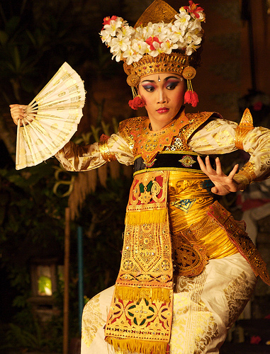
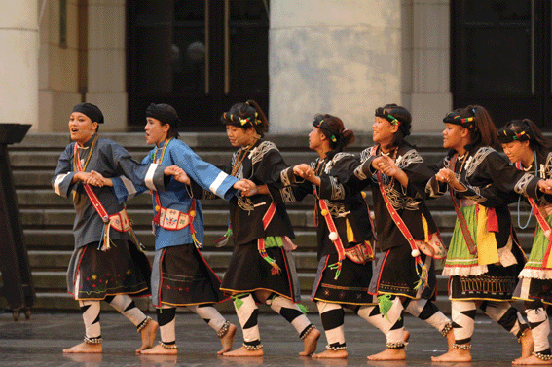
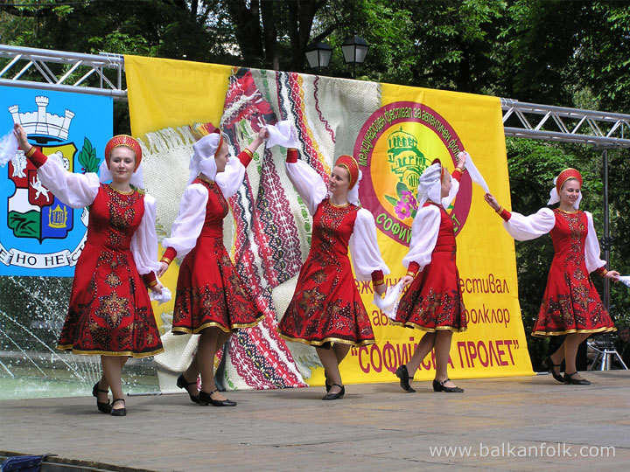
AND THE MAJORCAN DANCE GROUP “AIRES GABELLINS”

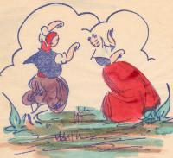

At 8 pm in the Auditorium of Cap Vermell Center

Cala Rajada

Entrance free

